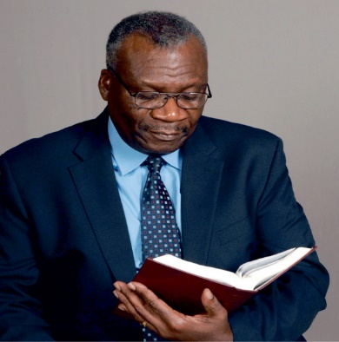
Rev. Dr. Robert L. Hobbs
25th Pastoral Anniversary
Metropolitan Baptist Church
We wish to thank you in advance for being a patron. The cost for a patron
is $15.00 for individuals and $20.00 per couple. You may mail your Patron List
to Metropolitan Baptist Church, Attention Pastor’s Anniversary, 125 County Street,
Suffolk, VA 23434 or email it to info@metropolitanbaptist1.org (Subject: Pastor’s
Anniversary). Please include your check or money order payable to Metropolitan Baptist
Church with “Pastor’s Anniversary” in the memo line. DEADLINE: July 24, 2024.

Please PRINT CLEARLY and feel free to make additional copies, if needed.

Patrons of: Contact #:

